Ex. No.: 9

Date:

**VIEW, INDEX, SEQUENCE**

**AIM:**

To create view, index and sequence on the given relation.

Questions:

Create a view with name ‘std_view’ using STUDENT table which holds the value of register number, name and DOB of student.

**Output:**

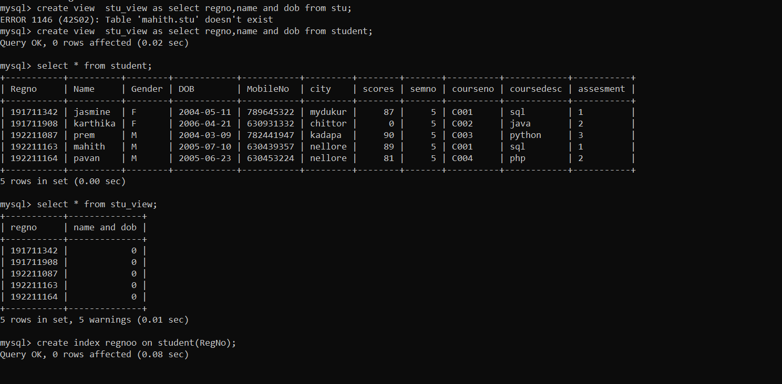

**RESULT**:

The records from the tables are displayed using JOIN using EquiJoin,InnerJoin, OuterJoin.